**Assignment 3**  
**E-Commerce Website Redesign**

|  |  |
| --- | --- |
| **E-Commerce Website:** Toronto Toys | (https://www.torontotoys.ca/) |
| **Team Members:**  Suyash Kulkarni  Abhishek Gaur  Tarandeep Singh  Suyeon Jang  Yejun Son |  |

**Introduction**

Toronto toys is the online platform dedicated to providing diverse range of toys to the resident of Toronto and other parts as well. This e-commerce website was launched in 2013 and since then providing the quality products as best price.

**Reasons for selecting this site:**

* There is a huge navigation on the landing page of the website without any differentiation which makes it difficult for the user to navigate through products.
* They have used images for major categories which is consuming more space in website page.
* On the right corner chat with us and rewards icons are overlapping and make it hard for user to click on one of them.
* Product images lacks description and images used are of different sizes rather being uniform in design.
* The website lacks in organizing the items properly on the website as random things appears while scrolling the page. Proper orientation should be applied on the page.
* The hover effect on the product is not proper it turns the image greyer, and it looks blurry.
* Login / Sign Up page also contains unnecessary big navigation for all the categories.
* Footer is not properly organized as it contains description about website which looks odd.

**Screens we are working on:**

**Landing Page:**

* Existing images of the landing page for the website
* Changing the navigation panel.
* Adding banner images instead of images for categories.
* Fixing the overlapping design issue for chat with us and rewards.

**Menu / Navigation Page:**

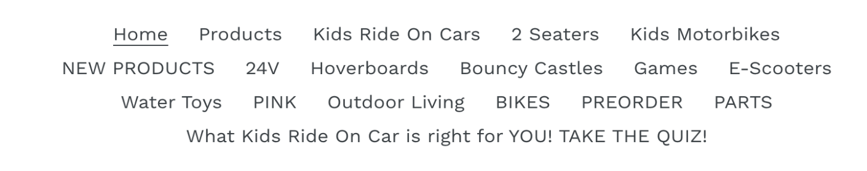

* The main navigation panel is not simplified as per user’s perspective.
* Changing the navigation panel and making it as simplified which will focus more on user interaction with the website.

**Product Page:**

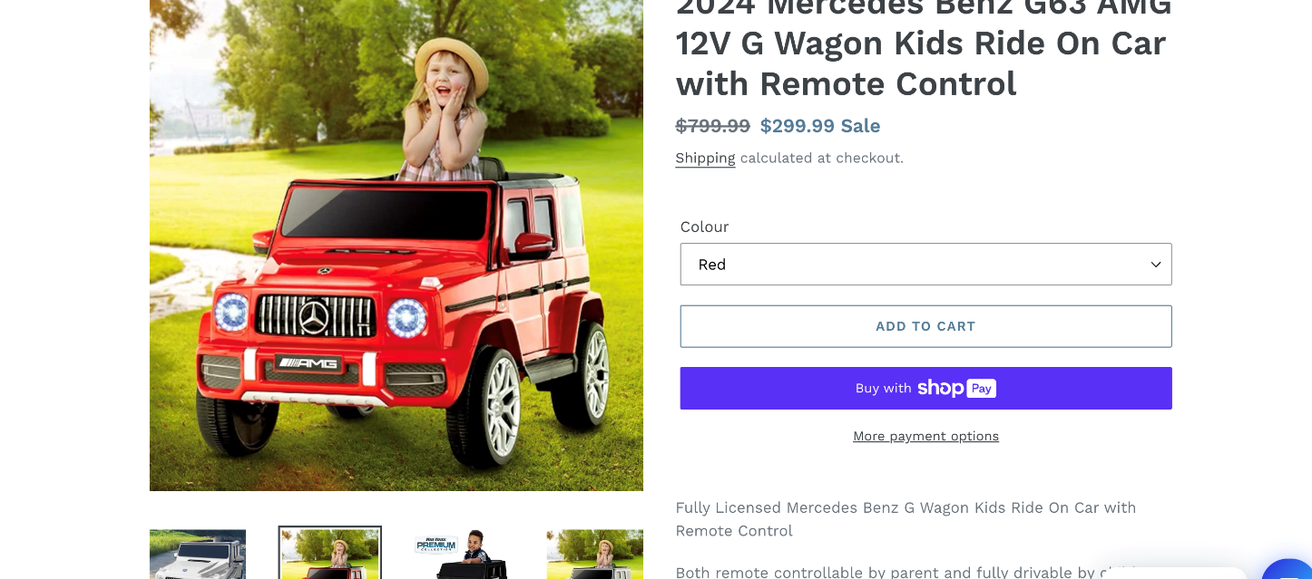

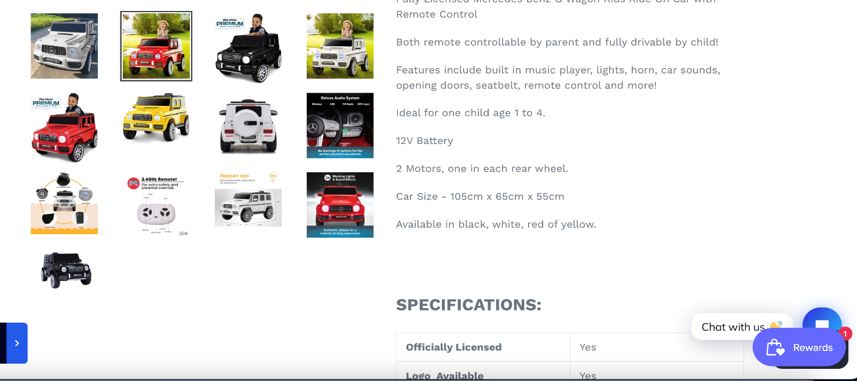

* The page orientation is not properly divided and organized in a proper way.
* Suggestion appears on the left side and then there is a whitespace in whole page which looks weird from users' perspective.
* The colour options acquire additional space in the page which could have been optimized with using banner or sliders or colour selection for the same models.

**Checkout Page:**

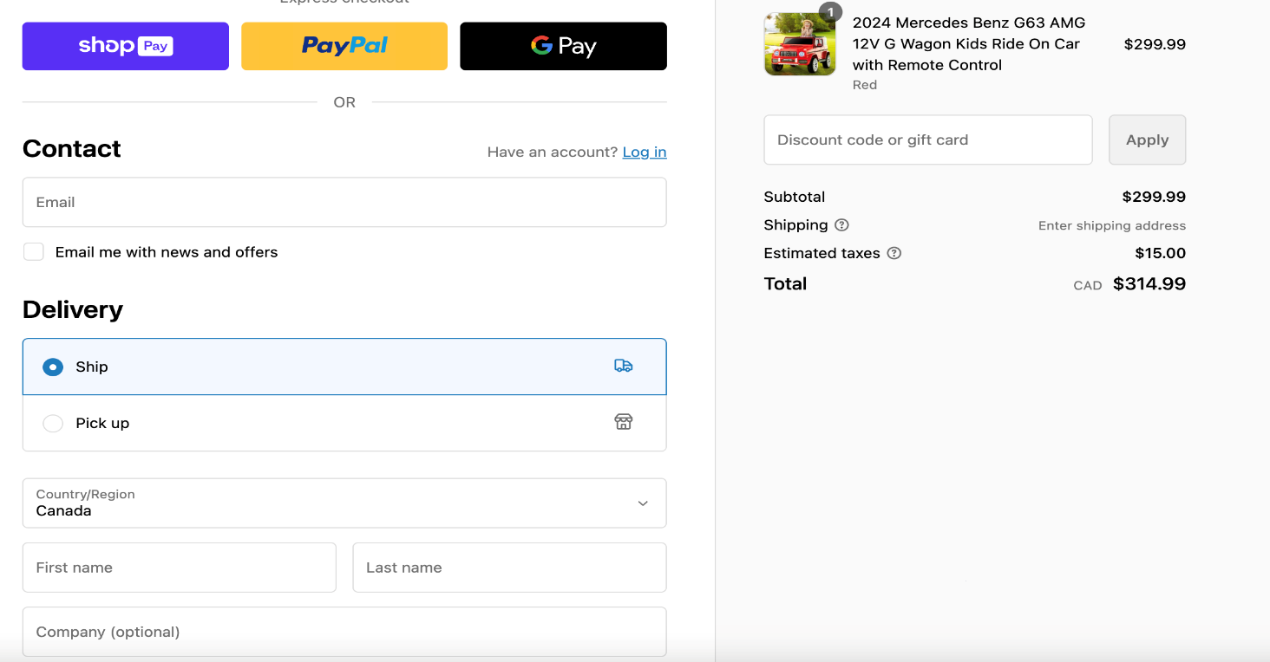

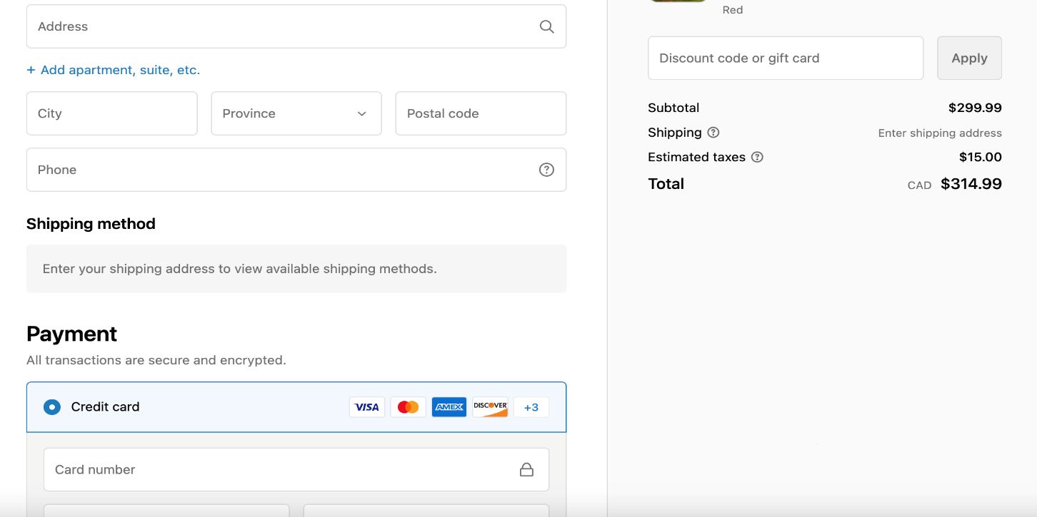

* The page has a long form to fill which included more scrolling for the user.
* The item selected is sticked to the right side of the page and again there is a lot of white space below that section.
* The credit card option is by default selected and other options are not properly organized.

**Sign Up / Register Page:**

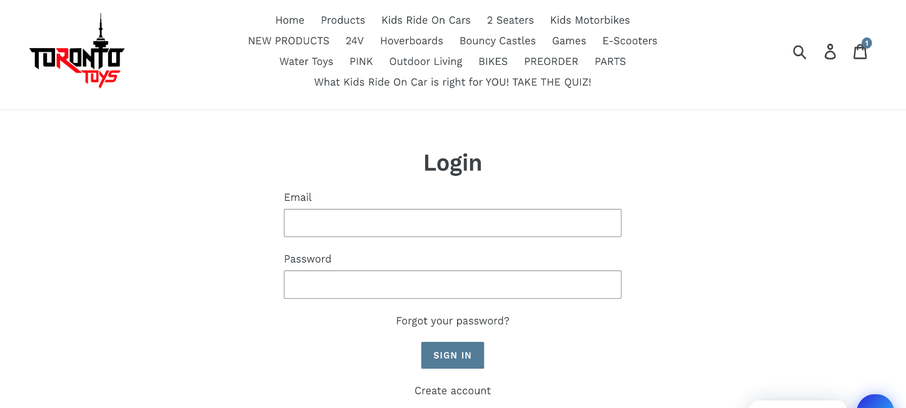

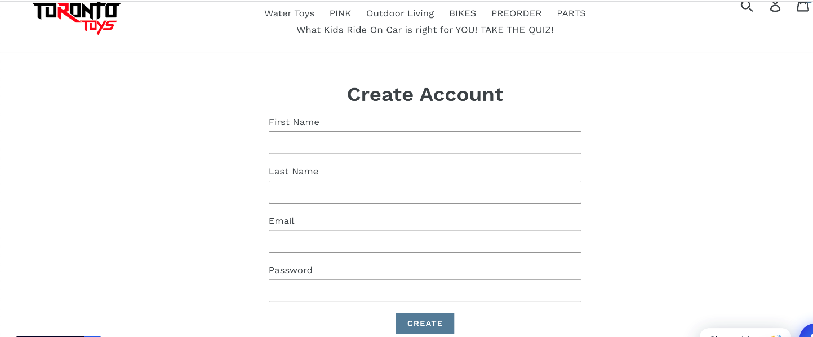

* Lots of white space and content is organized in the centre.
* The page also contains the navigation bar which is not appropriate according to the current page.

**Research and Analysis**

Understanding Needs and Pinpoints; We will conduct surveys. Analyse customer reviews to gain insights into what users looking for in a toy E-commerce platform and identify any challenges they might be facing.

Taking Preferences into Account; We will carefully examine user preferences regarding product variety, pricing, ease of navigation, customer service quality and overall shopping experience.

**Interview:**

After interviewing two elderly person who were willing to order few toys for their children and took feedback from them after they have visited the website. All the points are summarized below are following:

1. Dropdown navigations should be there instead of bunch.
2. Product’s Display should be more organised. (images can’t be of different sizes)
3. At Home page it has a long scroll.
4. At the footer they should be more quick links and FAQ’s
5. There should be social media’s links if they exist.
6. There must be a About page.
7. Headlines should be clickable.
8. There must be different components in compared to make a Home page more reasonable.
9. For limited time offers there should be banner images for that.
10. The hover effect is making the image more blur.

**Competitors Analysis**

The main competitors for Toronto toys are:

|  |  |
| --- | --- |
| **Mattel toys**  Mattel toys is an American based toys store whose headquarters is in EL Segundo, California. It is one of the largest and most used toys websites used globally for buying toys. Mattel was founded in 1945 by Harold Matson and Elliot Handler. |  |

**Product Range**

Mattel produces a diverse range of toys, games, and entertainment products. Their product lineup includes Barbie dolls, Hot Wheels, Fisher-Price toys, baby products, Action figures and toys based on popular franchises.

**Design Differences:**

The website is more focused on the range of the products they are providing.

All the images are of same sizes with proper description.

There is about us page and also the contact details mentioned in the website page.

They have mostly used banner images for advertisements or for new products arrival.

**Toys “R” Us**

|  |  |
| --- | --- |
| Toys “R” Us was founded in 1948 by Charles Lazarus as a furniture store for children. Over the years the store evolved into a prominent toy store retailer and became one the largest and most recognized toy chain in the world. |  |

**Product Range:**

* + - The range of toys, games, dolls, action figures, baby products, educational toys, electronics, and more.

**Design Differences:**

* They have a well-designed navigation bar for easy access.
* They also have an attractive filter page for age groups which allows user to filter it easily based on age.
* The major design change is the products have an auto scrolling design for the products which are in display for advertisement.

**Analysis based on needs:**

To identify current user experience needs, pain points and preferences of the Toronto Toys website we will consider design scenarios and factors based on best practices and specific expectations of online toy shopping channels It is important not to have direct access to Toronto Toys website specific and usage data over This study is a general reflection. Here are some key considerations.

**User requirements**

* **Easy to navigate and search:** Users need an intuitive web design with clear navigation to easily find toys by category, age, make, or specific features. Effective assessment activities are essential to quickly reach the desired results.
* **Product details:** Users need detailed product descriptions, pictures, notes, and customer reviews to make informed purchasing decisions. Information about toy parts, age appropriateness, and safety is important.
* **Safe and smooth shopping experience:** Users need a secure and easy online shopping experience, including secure payment options, a transparent checkout process, and order tracking.
* **Responsive thoughts:** Users expect a website optimized for devices including desktops, tablets and mobile phones, providing a consistent and seamless experience regardless of the device used.
* **Customer Support and Support:** Users appreciate accessible customer support, including live chat, email, or a support line for questions, concerns, or assistance during the purchase process.
* **Obvious pricing and discounts:** Users need clear pricing information, visible discounts, and any ongoing promotions or communications to assess affordability and value for money.

**Points of pain:**

* **Slow web speed:** When the website is slow to load, users can experience frustration, resulting in a poor user experience and potentially abandoned visits.
* **Hard credit cards:** Delayed or confusing checkouts can prevent users from completing their purchases, leading to cart abandonment.
* **Lack of variety:** Users may be unhappy that the site has few toys or doesn’t cover different age groups and interests.
* **Inappropriate or Inaccurate Information:** Incomplete or inaccurate product descriptions, missing pictures, or inadequate information about the toy can cause uncertainty and hesitation in purchasing
* **Ineffective detection function:** If the search function doesn’t return relevant results or is difficult to use, users may struggle to find what they’re looking for, affecting their overall experience.

**User Preferences:**

* **Personal recommendations:** Users appreciate personalized recommendations based on their browsing history, preferences, or purchase history, allowing them to identify relevant games.
* **Easy-to-use links:** Users want beautiful graphics, a clear call to action, and an intuitive layout that guides them through the site effortlessly
* **Incentives and Loyalty Programs:** It encourages users to come back and interact with the site regularly through loyalty programs, discounts, or incentives for repeat purchases.
* **Convenient payment options:** Satisfy user preferences by providing secure payment options including credit/debit cards, digital wallets, and other popular payment methods.

**Potential strengths:**

* **Miscellaneous Products:** Offering a range of toys that cater to different ages and interests can be a strength, appealing to a wider customer base.
* **Clarify taxonomy and navigation:** An intuitive menu and classification system can help users easily find which toys they find improve the overall user experience.
* **Considerations of Responsibility:** If the website is optimized for different devices (desktop, tablet, smartphone), this ensures accessibility and a consistent experience for users across platforms.
* **Customer reviews and reviews:** Including customer reviews and ratings on product pages can build trust and help users make informed purchasing decisions.
* **Secure Checkout Method:** Providing a safe and seamless shopping experience with multiple payment options can build user confidence and encourage completed purchases.
* **Integrating Social Evidence:** Showing social media followers, likes, or shares makes potential customers feel trusted and liked.

**Potential weaknesses:**

* **Resource Information Available:** Insufficient product information, including descriptions, images, and specifications, can prevent users from making an informed purchasing decision.
* **Mismatched images and logo:** The lack of a consistent and unified design can create a fragmented user experience and negatively affect a brand’s image.
* **Extreme or aggressive thoughts:** A cluttered layout, too many pop-ups, or too much text on a single page can overwhelm users, making it difficult for them to focus on specific actions.
* **Hard credit cards:** A long or confusing checkout process with too many steps or mandatory accounting can lead to cart abandonment and reduced sales.
* **Lack of clear calls to action (CTAs):** Vague or unclear CTAs can confuse users and prevent them from visiting the website and performing their desired actions.
* **Slow loading time:** Slow loading speeds can frustrate users and lead to high bounce rates, which affect the overall user experience and SEO rankings.

**Areas Of Improvement:**

* **Detailed Resource Information:** Provide thorough product descriptions, high-quality images, videos, and clear information to help users make informed purchasing decisions.
* **Easy to use navigation:** Optimize web navigation to ensure a clear and logical structure with easy-to-navigate categories and subcategories. Use intuitive menus and filtering options to help users find toys faster.
* **Improved credit cards:** Simplify the purchase process by reducing steps and reducing friction in the buying journey. Provide guest login options, save cart activity, and display progress indicators to keep users up to date on checkout progress.
* **Responsible Design:** Ensure that the site is fully optimized for mobile devices and for users who primarily access the site through smartphones and tablets. Find convenient layouts, fast load times and easy navigation across all screen sizes.

**Header Wireframe:**

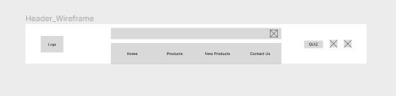

We are enhancing the user interaction with only four models of navigations because in the current website it is untidy and looks uncomfortable for a user to navigate products.

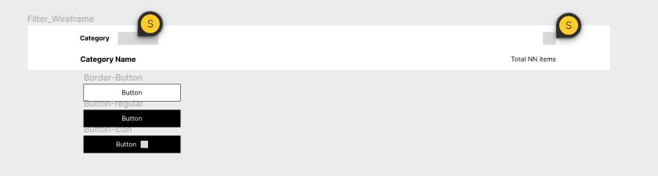**Filter Wireframe:**

We have additionally changed the remaining categories into filter format due to easy accessibility instead of looking uncultured and unfriendly.

**Pending**

* What changes you’re making to the layout of your screens
* If you are adding/deleting features— explain why you are doing that
* Usability testing. Did people understand your redesign?
* What types of interactions are you intending to put on each screen? How will it transition?

**Thanksgiving Banner Wireframe:**

* Furthermore**,** for festive seasons we have created a banner for communicating the holiday deals and sale on top.
* Uncluttered the “Chat with us” and Reward menu buttons on the screen (visible in the Figma wire frames).
* Slider has been added and the deal of the week has been added on the hero section where it will slide automatically after 8 seconds.
* Product categories has been separated to inform the customers what type of product to look for and if that product has further subcategories or not.
* Navigation bar is simpler and with lesser options and a category button which is dropdown when hovered on.
* Search bar is moved under the navigation.

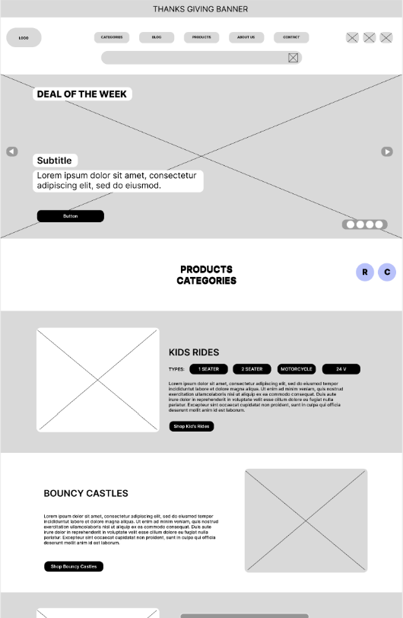

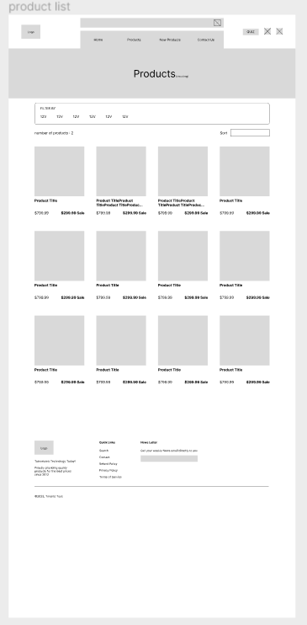

**Product List Wireframe:**

With the better navigation bar and well-arranged images of product display and descriptions in compared to present one.

**Product detail Wireframe:**

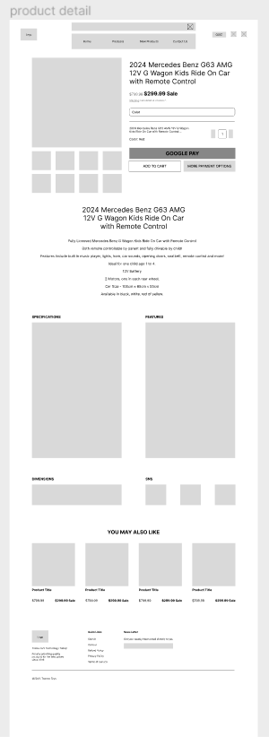In the detailed section we added the products image with different angles and video just below the main frame image with the 2 rows and 4 columns section with the brief of specifications and features columns.

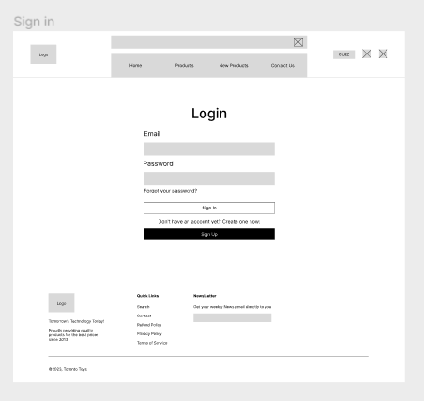**Sign in Wireframe and Create Account:**

With the compressed footer and 4 columns of navigation bars the sign in page looks decent.

